AI WeatherWise - Deliver Intelligent
Weather Forecasts and Insights.

Team ID : SWTID-2026-4935 Team Size : 5 Nos.

Team Leader : | Rakshavi.V
Team member : | Raihana Fathima.S
Team member : | Preetheeswari J
Team member : | Priyanka S
Team member : | Priyadarshini M

Description

AI WeatherWiseis a RESTful backend application developed to provide weather information together with AI-powered explanations and recommendations.
The system is developed using Node.js and Express.js as the backend technologies, while MongoDB with Mongoose is used for storing application data. The application also integrates Google Gemini AI to convert weather information into understandable summaries and useful recommendations.
The backend provides APIs for user authentication, favorite-location management, weather retrieval, and AI-based weather insights. Security is handled through JWT authentication and bcrypt password hashing.
The application also includes error-handling mechanisms, request validation and sanitization, and fallback functionality so that selected API operations can continue even when an external API key is unavailable.

Scenario-Based Case Study

Background
Priya is an event coordinator who regularly organizes outdoor events such as college functions, exhibitions, sports activities, and cultural programs. Weather conditions can have a major impact on the success of these events, so she needs quick and understandable weather information before finalizing plans.
AI WeatherWise provides a centralized backend that allows Priya to check the weather of different event locations, save frequently used locations, and receive AI-generated recommendations based on the expected environmental conditions.

Problem
Checking weather information from different sources and interpreting raw weather measurements can be time-consuming for event organizers.
- Difficulty monitoring weather conditions for multiple event locations.
- Raw temperature, humidity, and wind data may be difficult to interpret.
- Unexpected weather conditions can affect outdoor event arrangements.
- Lack of AI-based recommendations for event preparation.
- Need for secure user and location management.
- Requirement for a single backend service to handle weather and AI operations.

Solution
AI WeatherWise acts as a centralized backend that retrieves weather information and uses Google Gemini AI to provide meaningful explanations. The system allows event organizers to manage their saved locations and receive recommendations based on current weather conditions.
For example, if strong winds or heavy rainfall are detected, the AI can suggest preparing alternative indoor arrangements or taking additional precautions. If the weather is suitable, it can provide recommendations for conducting outdoor activities.

Usage
- Register and securely log in to the system.
- Save event locations as favorite cities.
- Add, update, view, or delete saved locations.
- Retrieve current weather information for an event location.
- Generate AI-powered weather explanations.
- Receive suggestions for event planning based on weather conditions.
- Manage user information securely.
- Access all weather and AI features through REST APIs.

Outcome
AI WeatherWise helps event organizers make informed preparations by converting complex weather data into simple, practical information. The combination of REST APIs, MongoDB, JWT authentication, and Gemini AI provides a centralized solution for managing locations and generating weather-based recommendations.
The system can help reduce the impact of unexpected weather conditions by providing understandable insights that support better event planning and preparation

Software Requirements

The following software components are required to develop and execute the AI WeatherWisebackend ●Operating System: Windows 10/11, macOS, or Linux (supports cross-platform operations).
- Node.js (v16 or above): Runtime ecosystem running server logic and routing infrastructure.
- npm (v8 or above): Node package manager to control operational dependencies.
- Gemini AI SDK: Integration using @google/generative-ai for natural language insights.
- MongoDB: Document NoSQL engine storing users, posts, categories, comments, and analytics metrics.
- Postman: API verification toolkit to assert schema validation responses across administrative route shields.
- Code Editor: Visual Studio Code or similar IDE environment.

2. Hardware Requirements

- Processor: Intel Core i5 (8th Gen or above) / AMD Ryzen 5 or equivalent.
- RAM: 8 GB minimum (16 GB recommended for concurrent instances of MongoDB, processing layers, and execution nodes).
- Storage: 1 GB of available disk workspace.

Epic 1: PROJECT ARCHITECTURE
The AI WeatherWise application follows the MVC pattern to decouple business logic from data management. The Controller layer orchestrates weather fetching from OpenWeatherMap and generation of AI insights via Gemini, while the Model layer manages User and Location entities.
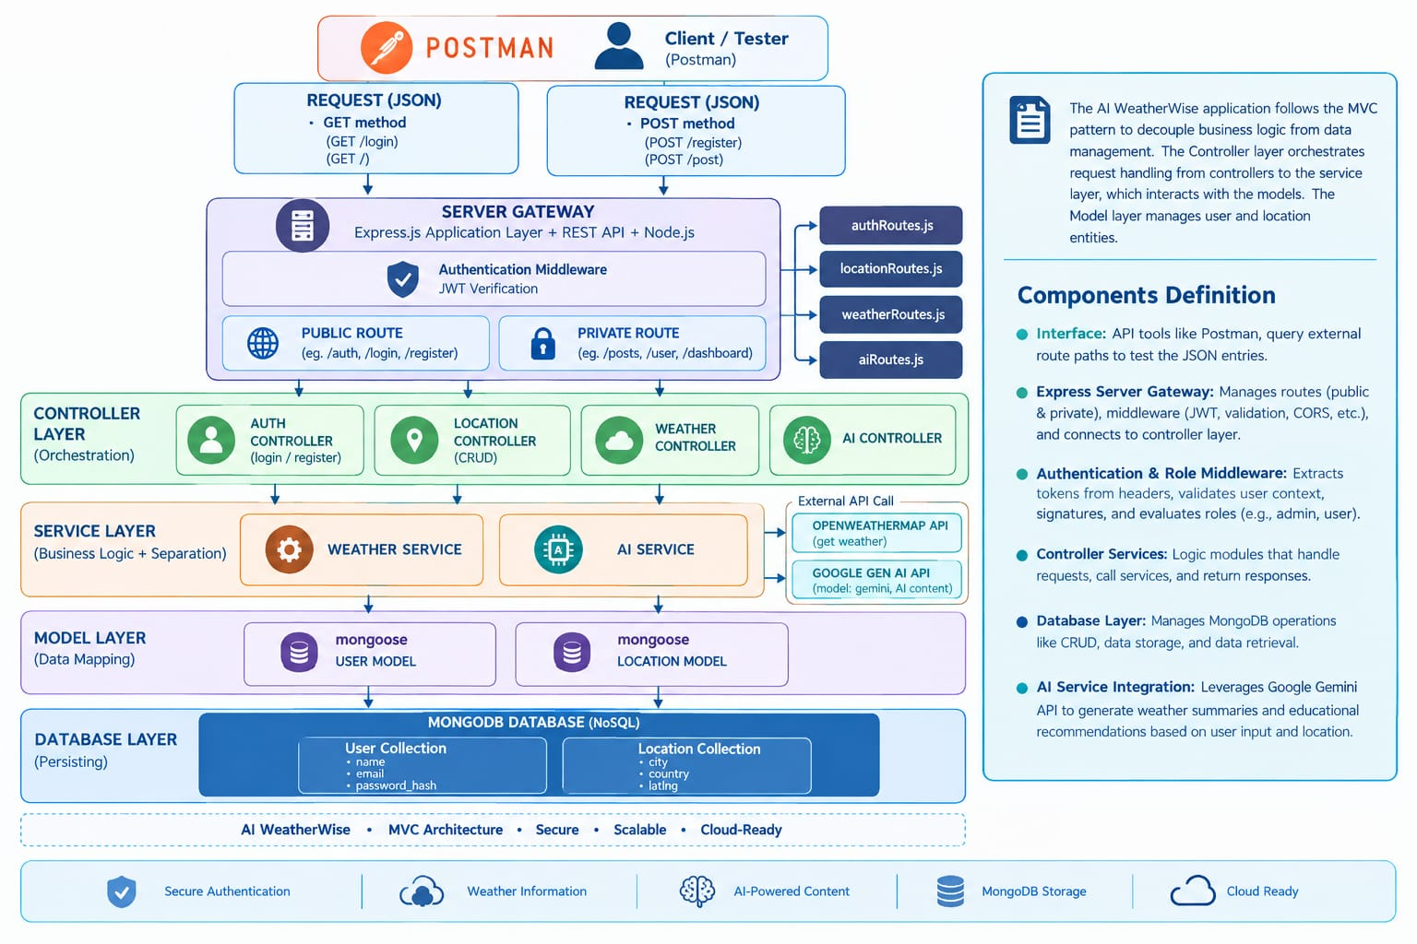
Components Definition
- Interface: API tools like Postman query distinct route paths to extract JSON entities.
- Express Server Gateway: Monitors network ports, maps explicit HTTP methods (GET, POST, PUT, DELETE), parses JSON payloads, and handles CORS headers.
- Authentication & Role Matrix Middleware: Extracts tokens from headers, validates user context signatures, and evaluates if the specific role satisfies authorization thresholds for guarded resource paths.
- Granular Services (Logic Modules): Enforces isolated domain rules for live weather data retrieval, fallback data handling, and AI prompt engineering.
- Database Interface Layer: Mongoose translates operational application logic into performant native MongoDB queries.
- AI Service Integration: Leverages @google/genai to generate weather summaries and personalized recommendations based on live temperature and conditions.
The AI WeatherWise technical architecture combines a three-tier system structure with MVC-based backend organization. Node.js and Express.js manage API processing, MongoDB and Mongoose provide persistent storage, JWT and bcrypt support security, OpenWeatherMap provides weather data, and Gemini AI provides intelligent weather insights. The separation of client, business logic, data, routing, controllers, models, middleware, and services provides a clear and maintainable structure for the project and supports future extension.
Components Definition
- Interface: API tools like Postman query distinct route paths to extract JSON entities.
- Express Server Gateway: Monitors network ports, maps explicit HTTP methods (GET, POST, PUT, DELETE), parses JSON payloads, and handles CORS headers.
- Authentication & Role Matrix Middleware: Extracts tokens from headers, validates user context signatures, and evaluates if the specific role satisfies authorization thresholds for guarded resource paths.
- Granular Services (Logic Modules): Enforces isolated domain rules for blog lifecycles (Draft, Pending Approval, Scheduled, Published), comment queues, and system reporting indicators.
- Database Interface Layer: Mongoose translates operational application logic into performant native MongoDB queries.
- AI Service Integration: Leverages @google/generative-ai to generate weather summaries and personalized recommendations based on live temperature and conditions.
The AI WeatherWise technical architecture combines a three-tier system structure with MVC-based backend organization. Node.js and Express.js manage API processing, MongoDB and Mongoose provide persistent storage, JWT and bcrypt support security, OpenWeatherMap provides weather data, and Gemini AI provides intelligent weather insights. The separation of client, business logic, data, routing, controllers, models, middleware, and services provides a clear and maintainable structure for the project and supports future extension.

Technical Architecture - Sub Topics

OBJECTIVES OF THE PROJECT
AI WeatherWise is a smart weather management backend designed to deliver accurate weather details along with AI-based insights. The application is built using Node.js and Express.js, providing a reliable REST API for handling client requests. MongoDB and Mongoose are used to store and manage user and application data efficiently.
The system integrates Google Gemini AI to convert weather data into simple explanations, useful suggestions, and personalized recommendations. It also includes features such as secure user registration and login, JWT-based authentication, favorite city management, weather data retrieval, input validation, and centralized error handling. Overall, AI WeatherWise combines conventional weather services with artificial intelligence to make weather information easier to understand and more useful for users.

1 .SYSTEM ARCHITECTURE

The main objectives of AI WeatherWise are to provide a centralized weather information service, securely manage registered users and favorite cities, retrieve current weather data through an external weather API, generate AI-based summaries and recommendations, maintain persistent application data using MongoDB, and provide a modular and maintainable backend architecture.

1.1 Client Tier / Frontend
The Client Tier serves as the visual interface of AI WeatherWise, allowing users to intuitively navigate live weather forecasts and personalized recommendations without directly handling raw API data. Implemented with React.js, HTML5, CSS3, and JavaScript, the frontend focuses on delivering a responsive and real-time interactive experience.
Core functionality provided by the Client Tier includes:
- Interactive Weather Dashboard: Presents real-time weather metrics—such as temperature, humidity, wind speed, and atmospheric conditions—using clear visual cards and dynamic icons.
- AI Recommendations Display: Dedicated interface panels highlight Gemini-generated natural-language summaries and smart outfit/activity suggestions based on current weather conditions.
- Favorite Locations Manager: Allows registered users to seamlessly add, view, update, or delete saved cities with real-time UI updates.
- Secure Session Management: Handles user registration and login workflows, keeping sessions secure across navigation routes using JWT authentication.
- API Integration & Verification: Utilizes Postman for API contract verification during development to ensure smooth data flows between user actions and backend services.

1.2 Business Logic Tier / Backend
The Client Tier manages all outgoing client requests and incoming server responses within the platform architecture. Whether rendered through a React.js single-page application (built with HTML5, CSS3, and JavaScript) or simulated via Postman during testing, this layer is responsible for gathering form inputs, enforcing pre-submission data validation rules, and displaying API results back to the user in a readable structure.

1.3 Data Tier / Database

The Business Logic Tier is implemented using Node.js and Express.js. It receives HTTP requests, applies middleware, performs authentication and authorization, executes application logic, communicates with external weather and AI services, and prepares JSON responses. Mongoose acts as the ODM between the application and MongoDB.

2. DATABASE DESIGN AND SCHEMA

The Data Tier uses MongoDB Atlas as the cloud database. Data is stored as BSON documents organized into databases, collections, and documents. The database stores user information, favorite locations, weather cache information, and other persistent application data.

3. DATA FLOW DIAGRAM

The Data Flow Diagram of AI WeatherWise illustrates how information moves between the user, application processes, databases, external Weather API, and AI service. The user provides authentication and location information to the system. The Weather Data Management module retrieves weather information from the external Weather API and stores or caches relevant data. The processed weather information is passed to the AI Insight Generation module, which produces understandable weather insights. The Recommendation Management module uses the weather conditions to generate practical suggestions. Finally, the system presents weather information, AI-generated insights, and recommendations to the user.

4. MODULES AND FUNCTIONALITIES

Level 1: User Request → Express Router → Authentication Middleware where required → Controller / Service → Mongoose Model or External API → Processing → JSON Response.

Level 0: User / Client → AI WeatherWise Application → MongoDB Atlas / External Weather Service / Gemini AI → Application → User / Client.

4.1 User Authentication Module
The User Authentication Module provides secure registration and login functionality for AI WeatherWise users. During registration, the user's basic details are validated and stored in the MongoDB database through the Mongoose model. Passwords are protected using bcryptjs before they are stored, so the original password is not saved directly in the database.

During login, the system retrieves the user record and verifies the submitted password against the stored hashed password. After successful verification, the backend generates a JSON Web Token (JWT). The token is returned to the authenticated user and is used to access protected API routes. Requests to protected resources pass through JWT middleware, which validates the token and identifies the authenticated user before allowing the controller or service to continue processing the request.

The module therefore provides the authentication flow: User Registration/Login → Validation → MongoDB User Record → Password Verification → JWT Generation → Protected API Access. This approach supports secure account access and helps prevent unauthorized use of protected weather, favorite-city, and account-management operations.

4.2 Favorite City Management Module
Allows authenticated users to add, view, and manage their frequently visited or preferred cities. The module maintains a one-to-many relationship between users and their favorite locations. A representative endpoint is POST /api/favorites, which stores a selected city for the authenticated user.

4.3 Real-Time Weather Data Integration
Retrieves current weather information for a selected city using the configured OpenWeatherMap API. The Node.js backend uses Axios to communicate with the external weather service. A representative endpoint is GET /api/weather?city=. Retrieved weather information can optionally be stored in the weatherCache collection for efficient access.

4.4 AI-Driven Insights Module
Uses Google Gemini AI to analyze the retrieved weather measurements and generate easy-to-understand natural-language summaries and recommendations. The module can provide practical insights based on parameters such as temperature, humidity, wind speed, and precipitation. The generated aiSummary can be stored or refreshed in the weather cache using updateOne() or an equivalent Mongoose update operation.

4.5 Security and JWT Validation Layer
Provides authentication and authorization for protected APIs. User credentials are securely managed using MongoDB, bcrypt password hashing, and JWT tokens. During login, Mongoose operations such as User.findOne() are used to verify the user's account, while User.create() can be used to create new profiles. The JWT middleware validates incoming tokens and identifies the authenticated user.

4.6 CRUD Operations
Provides the basic Create, Read, Update, and Delete operations required for managing application data, particularly favorite cities and cached weather information. Protected CRUD requests pass through JWT validation middleware, which extracts the authenticated userId. Valid requests receive JSON responses, while invalid or missing authentication tokens result in an HTTP 401 Unauthorized response.

5. TECHNOLOGY STACK
The AI WeatherWise application uses a modern full-stack technology environment to provide weather information, user authentication, favorite-city management, and AI-powered insights.
- Frontend / Client: React.js, HTML5, CSS3, and JavaScript are used to create a responsive and interactive user interface.
- Backend: Node.js with Express.js is used to develop RESTful APIs, handle business logic, process requests, and manage communication between the frontend and external services.
- Database: MongoDB Atlas is used for cloud-based data storage, with Mongoose ODM providing schema definition and database interaction.
- Authentication and Security: JWT is used for user authentication and authorization, while bcrypt/bcryptjs is used for secure password hashing.
- External Services: OpenWeatherMap API provides real-time weather information, while Google Gemini AI is used to generate intelligent weather summaries and recommendations.
- Development Tools: Visual Studio Code is used for development, Postman for API testing, npm for package management, and Git/GitHub for source-code version control. Nodemon is used during development to automatically restart the backend server when code changes are detected.
- Configuration: dotenv is used to manage environment variables such as API keys, database connection strings, and authentication secrets securely.

6. SECURITY AND PERFORMANCE
Security and performance are important aspects of the AI WeatherWise architecture. The application uses multiple mechanisms to protect user information and provide efficient service.
Security Measures:
- JWT-based authentication is used to protect private APIs and verify user identity.
- bcrypt/bcryptjs is used to hash passwords before storing them in the database.
- Protected routes ensure that only authenticated users can access personal resources such as favorite cities.
- Environment variables are used to keep API keys, database credentials, and other sensitive configuration values outside the source code.
- Request validation and input sanitization help prevent invalid or potentially harmful data from entering the system.
- MongoDB Atlas access controls and secure database connections help protect stored application data.
Performance Measures:
- Database indexes can be used to improve the speed of frequently executed queries.
- Database connection management helps reduce unnecessary connection overhead.
- Weather responses can be temporarily cached to avoid repeated requests for the same location.
- Efficient API calls reduce unnecessary communication with external services.
- Asynchronous processing in Node.js helps the server handle multiple requests efficiently.

7. ADVANTAGES OF THIS ARCHITECTURE
The proposed architecture provides several advantages for the AI WeatherWise system:
- Improved Security: JWT authentication, password hashing, protected routes, input validation, environment variables, and database access controls provide multiple layers of protection.
- Scalability: The modular separation of frontend, backend, database, weather service, and AI service makes the application easier to expand.
- Better Performance: Database indexing, efficient API communication, asynchronous processing, and caching can improve application response time.
- Reduced API Usage: Weather caching minimizes repeated requests to the external weather service for frequently searched locations.
- Maintainability: Using separate modules and RESTful APIs makes the system easier to test, update, and maintain.
- Easy Integration: The architecture allows additional weather providers or AI services to be
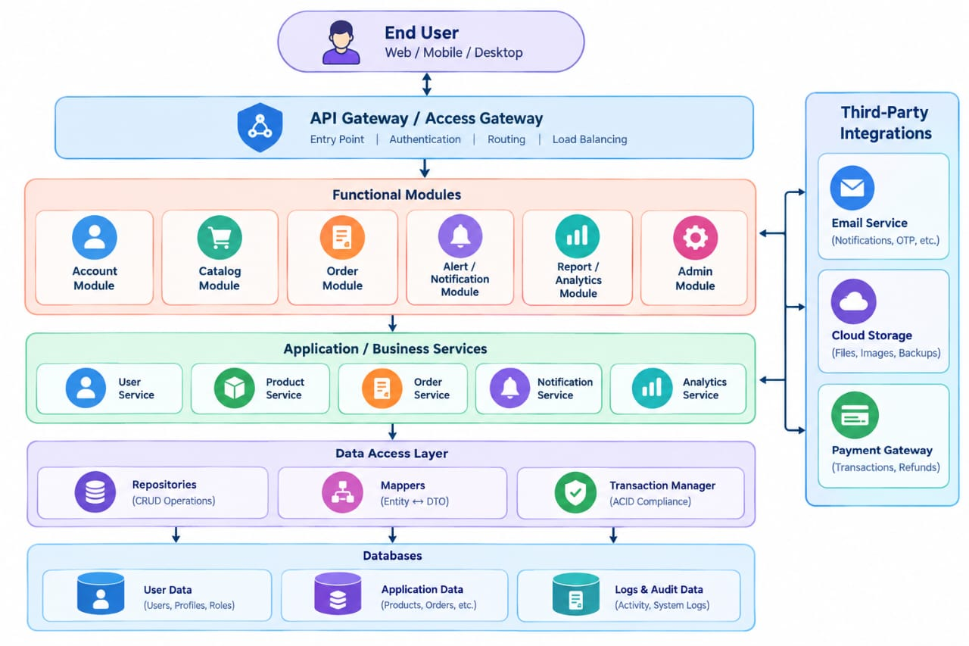

Entity-Relationship (ER) Diagram Description

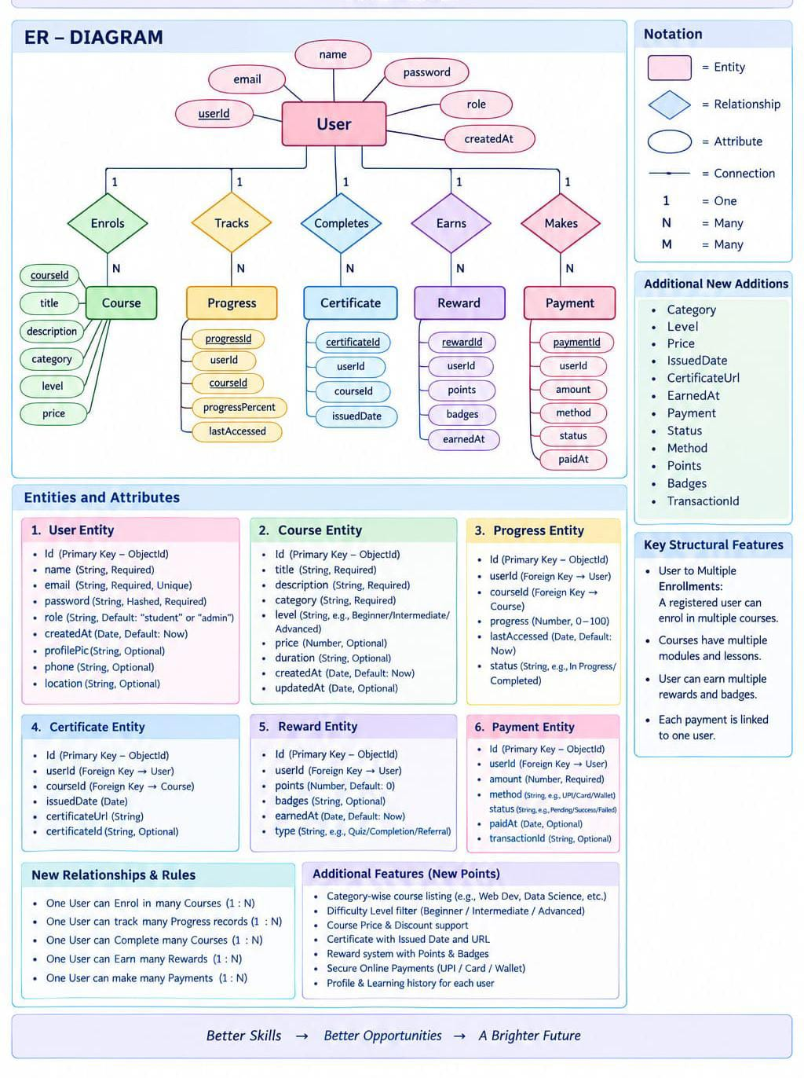

User Entity
- _id (Primary Key - ObjectId)
- name (String, Required)
- email (String, Required, Unique)

Location Entity
- _id (Primary Key - ObjectId)
- name (String, Required)
- address (String, Required)
- city (String, Required)
- state (String, Required)
- country (String, Required)
- latitude (Number, Required)
- longitude (Number, Required)
- createdAt (Date, Default: Current Date)
- updatedAt (Date, Default: Current Date)
- password (String, Hashed, Required)
- role (String, Default: "reader")

KEY STRUCTURAL MAPPINGS

One-to-Many Relationship
A one-to-many relationship occurs when a single record in one entity can be associated with multiple records in another entity. In the AI WeatherWise system, one user can have multiple favorite cities, while each favorite-city record belongs to a single user.
For example, a user may save cities such as Chennai, Bengaluru, Mumbai, and Delhi as favorite locations. Each saved location is associated with the corresponding user's unique ID.

Relationship:
User (1) → Favorite Locations (Many)
This relationship allows the system to securely manage user-specific favorite cities and ensures that users can access only their own saved locations.

KEY FEATURES
- User Authentication: Provides secure registration and login using bcrypt/bcryptjs password hashing and JWT-based authentication.
- Favorite City Management: Allows authenticated users to add, view, update, and remove their frequently used cities.
- Real-Time Weather Information: Retrieves current weather conditions from the OpenWeatherMap API for the selected location.
- AI-Powered Weather Insights: Uses Google Gemini AI to convert weather measurements into simple summaries and useful recommendations.
- CRUD Operations: Supports Create, Read, Update, and Delete operations for applicable application data, especially favorite locations.
- Data Management: Uses MongoDB Atlas and Mongoose to store and manage user profiles, favorite locations, and optional weather-cache information.
- Data Validation and Sanitization: Validates incoming data and helps prevent invalid or potentially harmful requests.
- Protected API Routes: Uses JWT middleware to restrict access to user-specific resources.
- Error Handling: Provides appropriate responses when authentication fails, locations are invalid, external services are unavailable, or database operations encounter errors.
- Weather Data Caching: Stores selected weather responses temporarily to reduce repeated requests to the external weather service and improve response efficiency.

USER FLOW

1. User Registration and Login
The user first creates an account or logs into an existing account using their credentials. The request is handled by the Express.js API and authentication controller. Passwords are securely hashed using bcrypt/bcryptjs, while successful authentication generates a JWT token for accessing protected resources.
Flow:
User → Express API → Authentication Controller → MongoDB → JWT Token → User

2. Favorite City Management
After successful authentication, the user can add, view, update, or delete favorite cities. Each protected request is verified by JWT middleware before the relevant controller or service performs the database operation using Mongoose.
Flow:
User → JWT Middleware → Favorite City Route → Controller/Service → Mongoose → MongoDB → JSON Response

3. Real-Time Weather Retrieval
The user selects or searches for a city to view its current weather conditions. The weather controller/service sends the location information to the OpenWeatherMap API. The received data is processed and returned to the user. If suitable cached information is available, the system can use the cache to reduce unnecessary API requests.
Flow:
User → Weather Route → Controller/Service → Weather Cache / OpenWeatherMap → Processed Weather Data → JSON Response

4. AI-Driven Weather Insights
After obtaining weather information, the relevant weather parameters can be passed to Google Gemini AI. The AI service generates a natural-language summary and practical recommendations based on the available weather data. The generated information can optionally be stored in the weather cache for later use.
Flow:
Weather Data → Gemini AI Service → AI Summary & Recommendations → Optional Cache → User Response

5. Secure Account Access
Authenticated users can access and manage their account-related information through pr
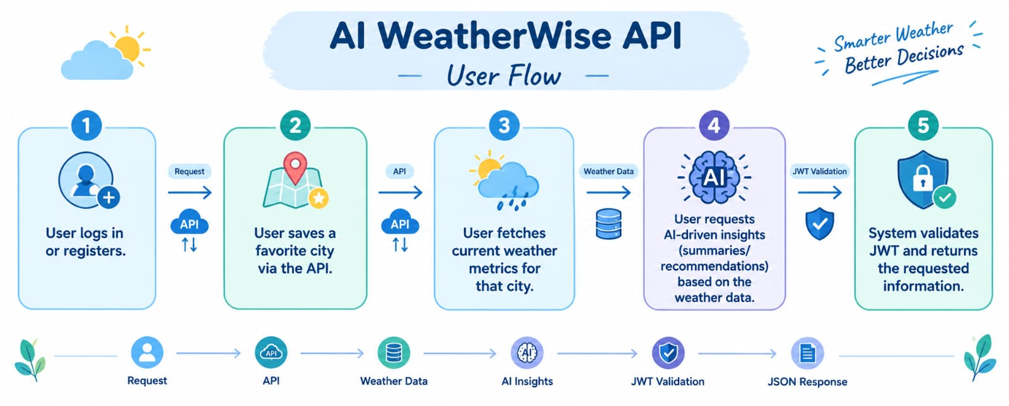

Roles and Responsibilities

Admin
- Account Administration: Oversees user user profile lifecycles, including account creation, status updates, and account deletions.
- System Monitoring: Tracks API health, server uptime, and application execution logs.
- Database & Access Control: Manages MongoDB schema integrity, index optimizations, and security policies.
- Maintenance & Backups: Coordinates routine system maintenance, key rotation, and automated data backups.

Registered User
- Account Management: Registers, logs in, and maintains personal profile details and credentials.
- Location Personalization: Creates, views, updates, and deletes saved favorite cities (CRUD operations).
- Real-Time Weather Access: Queries live temperature, humidity, and condition metrics for any global location.
- AI Recommendations: Interacts with the Gemini AI engine to receive smart weather summaries and tailored activity advice.

MVC Architecture Pattern
The AI WeatherWise backend uses the Model-View-Controller (MVC) pattern to separate database operations, processing logic, and routing interfaces:
- Model Layer: Handles data persistence and validation using Mongoose schemas for User and Location entities.
- Controller Layer: Contains application business logic, processing requests, calling weather/AI services, and sending JSON responses.
- View Layer: Functions as a headless REST API gateway, mapping endpoints and HTTP methods to their controllers without front-end HTML rendering

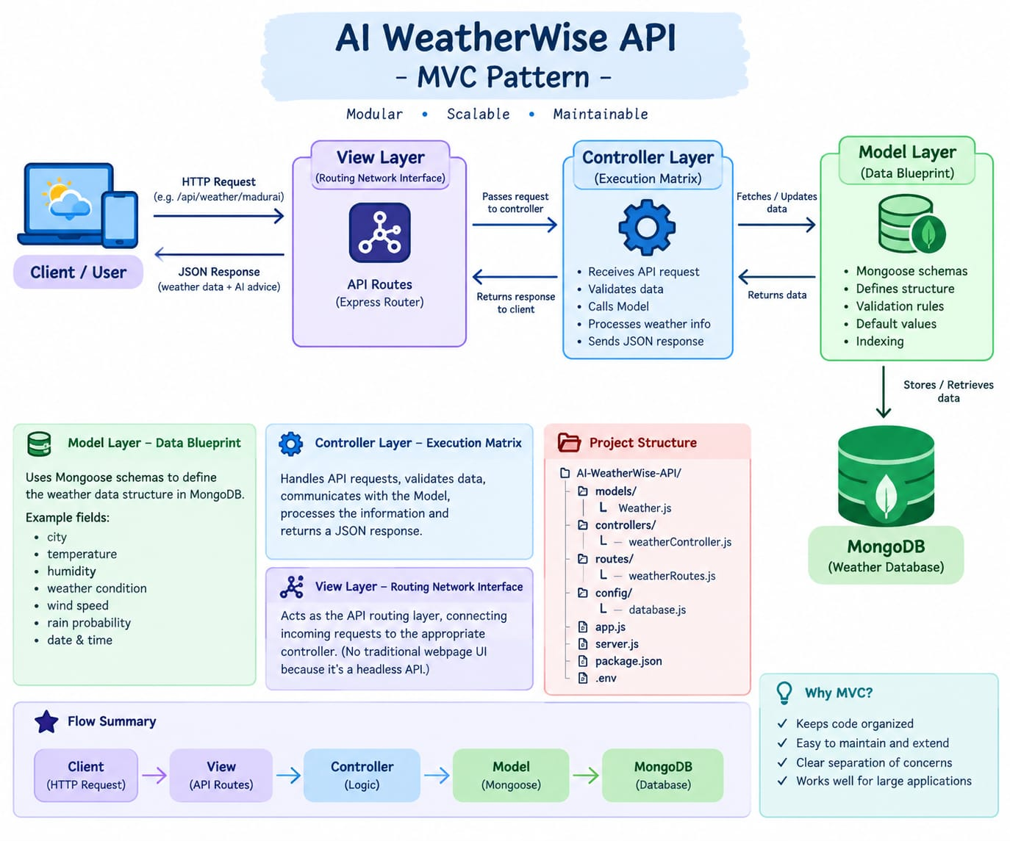

Model Layer (Data Blueprint)

Defines structure blueprints via strongly enforced Mongoose schemas mapping explicit fields into raw collection items inside MongoDB. It sets default states, indexing rules, and transformation parameters before validation persistence occurs.
Definition to write: Defines structure blueprints via strongly enforced Mongoose schemas mapping explicit fields into raw collection items inside MongoDB.

DBOperation: insertOne, findOne, updateOne
Tech: Mongoose Schema
Work: Database structure defines file/models/User.js, /models/Admin.js

Controller Layer (Execution Matrix)

The intermediary brain of the ecosystem. It captures request vectors from the execution routes, checks structural request constraints, delegates processing workflows directly to models, and packages the resultant output into standard JSON return arrays.
Definition to write: The intermediary brain of the ecosystem. It captures request vectors from routes, checks constraints, delegates work to models, and packages the resulting data into standard JSON responses.

Flow: USER Request -> VIEW (Routes) -> CONTROLLER -> MODEL -> DATABASE -> Response
Definition to write: In this pure headless backend, standard UI views do not exist. Instead, it lives as an API Routing Layer that links network requests on specified paths directly to controller logic.

Example: router.post('/register', registerUser)
Tech: Express.js Router
Work: User kudukura request ah vaangura gate
File: /routes/ - Routes folder
Tech: Node.js + Express.js
Work: Brain of the system. Full logic File: /controllers/ - Controllers folder

View Layer (Routing Network Interface)

In this pure headless backend service context, standard user-interface template views do not exist. Instead, the interface layer lives as an API Routing Layer. It links network requests on specified paths directly to their associated controller handler logic maps.
The integrated architecture combines three-tier separation, MVC responsibilities, user-flow modules, database references, external weather integration, AI processing, and JWT security. This organization keeps the backend modular, maintainable, and extensible while preserving a clear request-to-response path.

Epic 2: Project Setup and Configuration

Creating the Project Folder
- Create a new folder named AI Weatherwise
- Open the project folder in Visual Studio Code.
- Initialize the project using Node.js and install the required dependencies.

CREATING THE PROJECT FOLDER

The first step in developing the AI WeatherWise API is to create a dedicated project folder. This folder contains all the source code, configuration files, dependencies, database-related files, and backend modules required for the application.

Project Folder Creation
A new folder named “AI WeatherWise” is created on the development system. The folder is then opened in Visual Studio Code so that the complete backend project can be developed and managed in one place.

Initializing the Node.js Project
After opening the project folder in the terminal, the Node.js project is initialized using the following command:
npminit -y

This command creates the package.json file. The package.json file contains the project name, version, scripts, and information about the packages required by the backend.

Installing Backend Dependencies
The required Node.js packages are installed to provide the core functionality of the AI WeatherWise API.
- Express.js – Used to create the REST API server.
- Mongoose – Used to connect and work with MongoDB.
- bcryptjs – Used for secure password hashing.
- jsonwebtoken – Used for JWT-based authentication.
- cors – Used to enable controlled cross-origin requests.
- dotenv – Used to load configuration values from environment variables.
- @google/genai – Used to integrate Google Gemini AI capabilities.
The dependencies can be installed using:
npm install express mongoose bcryptjsjsonwebtokencorsdotenv @google/genai

Development Dependency
Nodemon can be installed as a development dependency. It automatically restarts the server whenever code changes are detected.
npm install --save-dev nodemon

2. SERVER SETUP

The AI WeatherWise backend server is developed using Node.js and Express.js. Express acts as the main server framework and handles client requests, API routes, middleware, and responses.
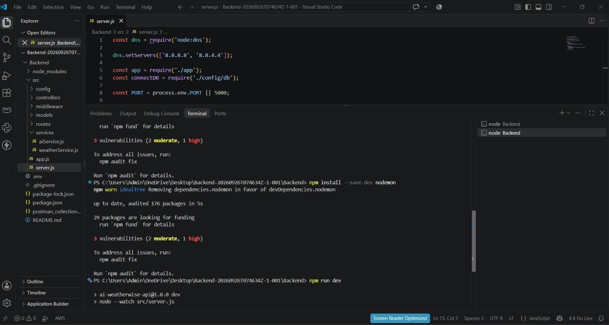

Creating the Express Server :

The main server file, such as index.js, is created in the project root directory. It acts as the entry point of the backend application.

Server Configuration
The server is configured to load environment variables, initialize Express, enable JSON request processing, configure CORS, connect to MongoDB, register API routes, and start listening on the configured port.
Basic server execution flow:
- Start the Node.js application.
- Load environment variables.
- Initialize the Express application.
- Configure required middleware.
- Connect to MongoDB through Mongoose.
- Register the API routes.
- Start the server on the configured port.
- Accept and process client requests.

Environment Configuration
Sensitive configuration values are stored in a .env file instead of being directly written into the source code.
PORT=5000
MONGO_URI=your_mongodb_connection_string
JWT_SECRET=your_jwt_secret
GEMINI_API_KEY=your_gemini_api_key

The .env file should not be uploaded to a public repository because it may contain database credentials, authentication secrets, or external API keys.

Middleware Configuration
Middleware processes requests before they reach the required API controller. The backend can use middleware for JSON parsing, CORS configuration, authentication, validation, sanitization, and centralized error handling.

MongoDB Connection
MongoDB is used as the database for storing persistent application data such as user accounts and saved locations. Mongoose provides the connection and data-modeling layer between the Node.js application and MongoDB.

Server Execution
After the configuration and database connection are completed, the Express server starts listening on the configured port. For example, when PORT is set to 5000, the local backend can be accessed through:
http://localhost:5000

Development and Explanation

The AI WeatherWise backend is developed using Node.js, Express.js, and MongoDB Atlas, following a modular architecture.
The backend separates:
- Routes,
- controllers,
- middleware,
- models,
- configuration, and
- utility modules
to improve code organization, maintainability, and scalability.

It provides REST APIs for user authentication, location management, weather information, and AIpowered services.

MongoDB is used to store user and location data, while Mongoose manages the database connection and schemas.

The backend also integrates external services such as the OpenWeather API for weather data and the Gemini API for AI-based functionality. Authentication and password security are handled using JWT and bcryptjs. This architecture enables secure and efficient communication between the frontend, database, external APIs, and AI services.

Core System Script Implementations :

- Application Entry Point (server.js) :The server.js file serves as the main entry point of the application. It initializes the
Express server, loads environment variables, configures middleware, establishes the MongoDB connection, registers API routes, and starts the server after a successful database connection.
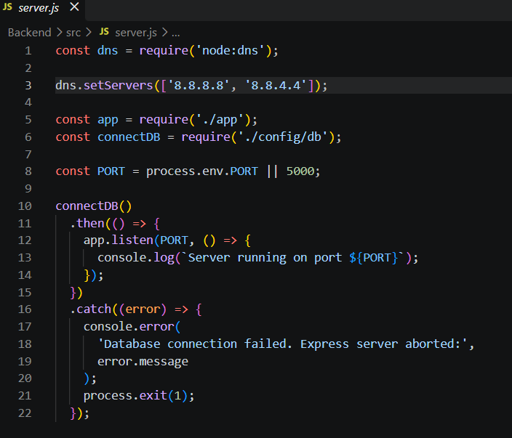

Environment Configuration :

Sensitive configuration details are stored in the .env file instead of directly writing them inside the source code.

Example:
PORT=5001
MONGO_URI = mongodb_atlas
JWT_SECRET=your_jwt_secret
OPENWEATHER_API_KEY=your_openweather_api_key
GEMINI_API_KEY=your_gemini_api

BACKEND REQUEST FLOW

A typical AI WeatherWise API request follows a structured path through the backend:
Client / Postman
↓
Express Server
↓
Route
↓
Middleware
↓
Controller
↓
Service / Model
↓
MongoDB or External Weather / Gemini Service
↓
Controller
↓
JSON Response
↓
Client

This layered request flow keeps responsibilities separated. For example, the controller handles request processing, the model handles database interaction, and the service layer handles communication with external weather or AI services.

5. SECURITY AND CONFIGURATION

Security is considered during the server and backend setup. User passwords are hashed using bcryptjs, JWT is used to protect authenticated routes, and sensitive configuration values are stored in environment variables.
- Passwords are never stored as plain text.
- JWT tokens are verified before protected operations are processed.
- Sensitive API keys and database credentials are kept in the .env file.
- Input validation and sanitization can be applied to reduce unsafe requests.
- Centralized error handling provides consistent API responses.

6. RUNNING THE PROJECT
After completing the setup, the project can be executed using the following steps:
- Open the AI WeatherWise project folder in Visual Studio Code.
- Open the terminal inside the project folder.
- Install dependencies using npm install.
- Configure the .env file with the required values.
- Ensure MongoDB is available.
- Start the backend using the configured npm start command or development command.
- Verify that the server is running on the configured port.
- Test the API endpoints using Postman.
Epic4: Database Configuration
API Testing Demo :

1. Configure MongoDB:
Mongoose was installed in the Node.js backend project using the following command:
npm install mongoose
Mongoose is an Object Data Modeling (ODM) library for MongoDB and Node.js. It allows the application to work with MongoDB using JavaScript objects and schemas.

Create Database connection:
The backend uses the MongoDB URI stored in the .env file to establish a connection with MongoDB Atlas.
Example database connection file: config/db.js
const mongoose = require('mongoose');

constconnectDB = async () => {
try {
await mongoose.connect(process.env.MONGO_URI);

console.log(
`MongoDB Connected: ${mongoose.connection.host}`
);
} catch (error) { console.error(
'MongoDB connection error:',
error.message
);
process.exit(1);
}
};
module.exports = connectDB;

Mongoose Schema Definitions
Location Schema:

Defines the structure of location data, including city, country, and associated user.

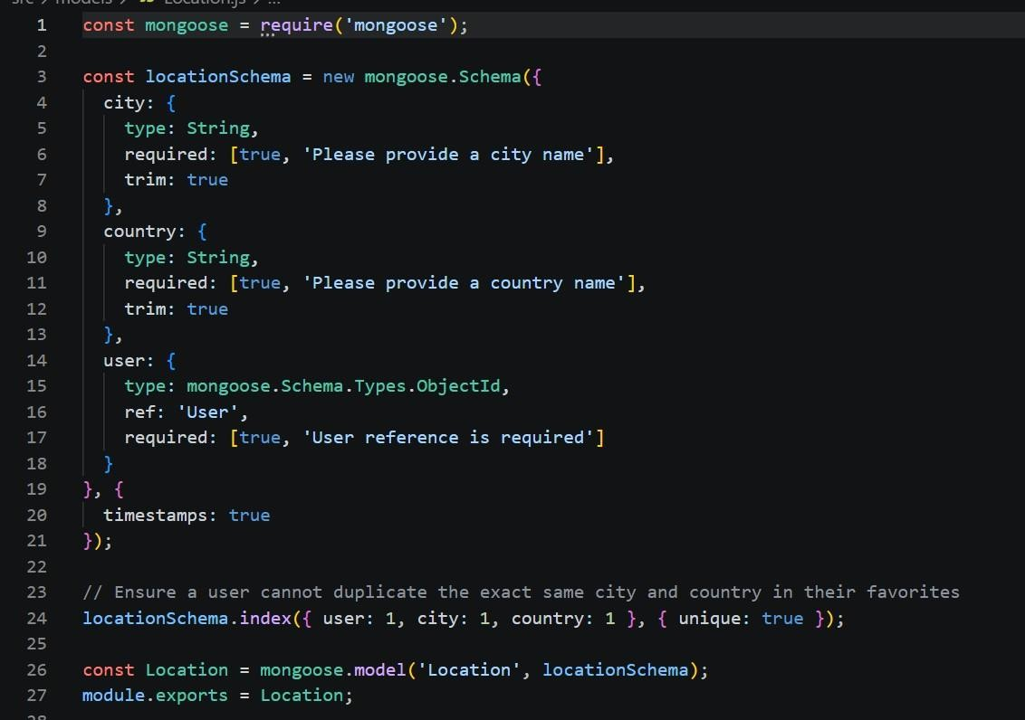

User schema:

Defines the structure of user data, including name, email, and password.

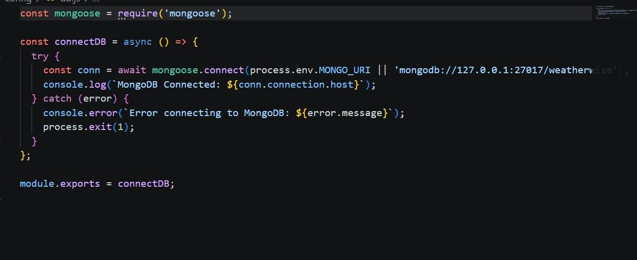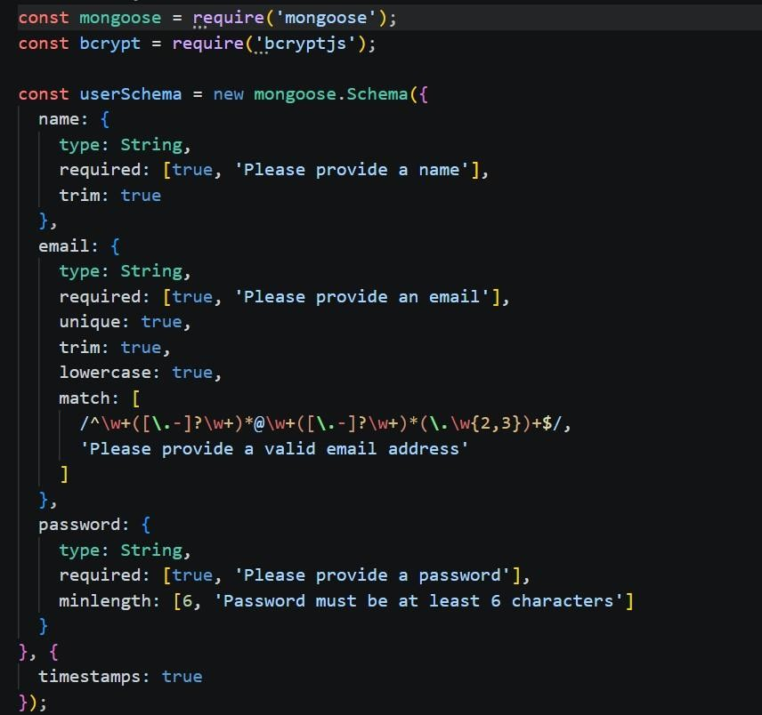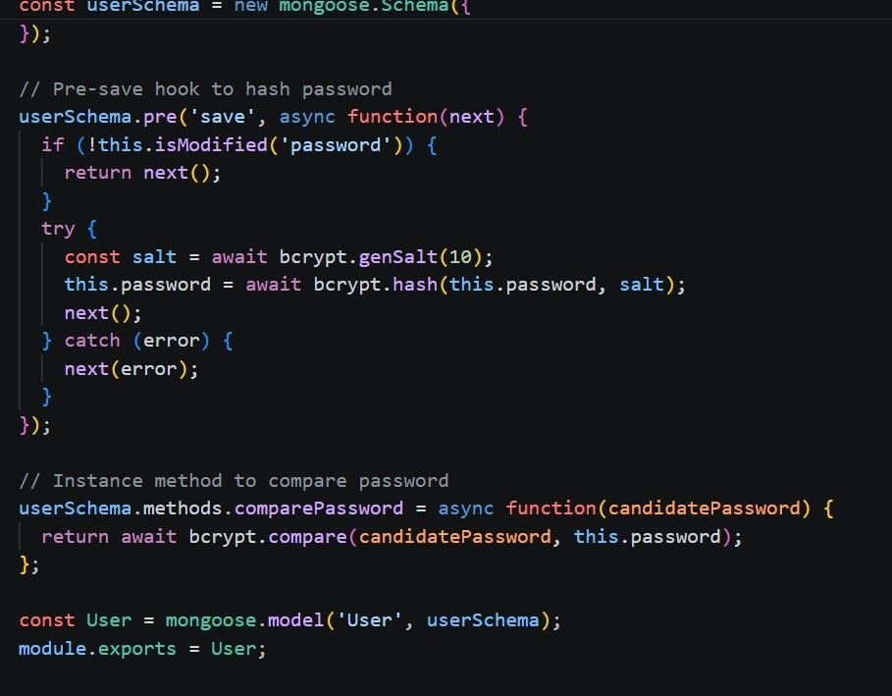

Database Connection:

Establishes a connection between

the Node.js application and MongoDB

using Mongoose. It uses the

MONGO_URI from the environment file

and displays a success message when

the connection is established.

Project Executions

The AI WeatherWise backend can be executed locally using Node.js.

Before starting the application, the following conditions should be satisfied:

- Node.js is installed.
- npm is available.
- Required dependencies are installed.
- MongoDB is available.
- Environment variables are configured.
- Required API credentials are correctly configured where applicable.

Running the Backend Server:
Install all required dependencies:
npm install
Start the development server:
npm start
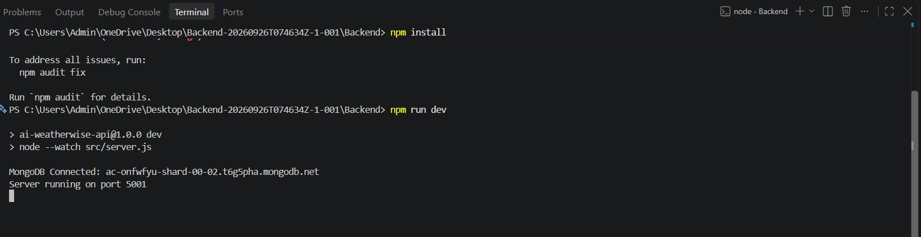
After successful execution, the server connects to MongoDB and starts listening for incoming API requests.

API Testing :
Register API:
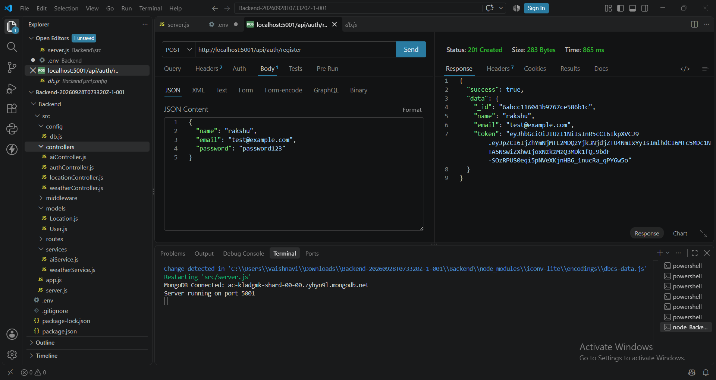
Login Api:
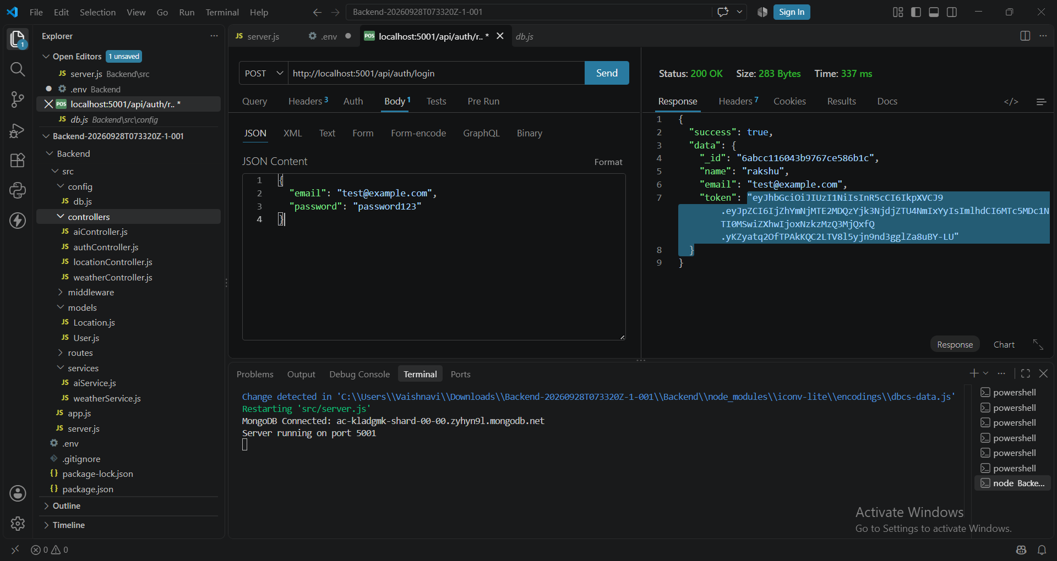
Weather Testing:
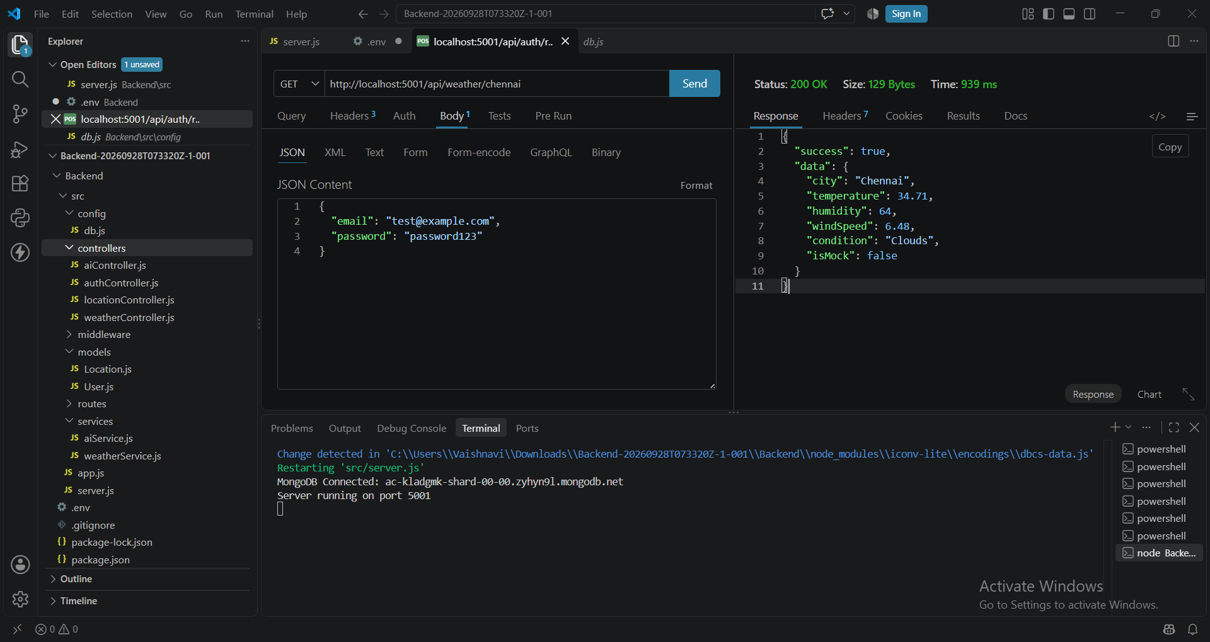
Weather Recommendation :
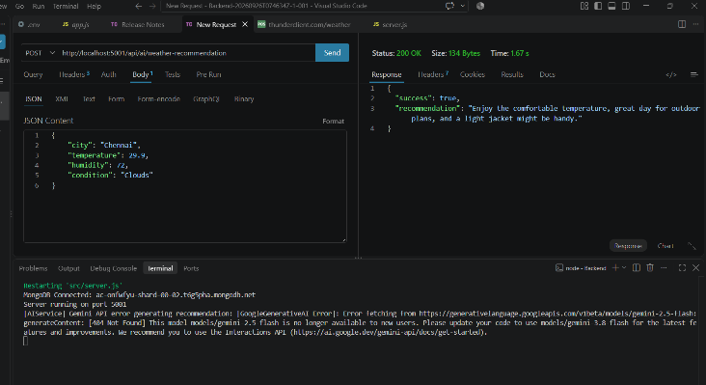

API testing video link: API TESTING .mp4
Demo Video Link: Backend demo.mp4
CodeDrive: Code

